# Review and Retrospective

Sprint 2 Review and Retrospective for Demo at SAL 322 on April 17th 2018 6pm.

## Verbal feedback

The grader asked us to run our black-box tests.

The grader asked us to run our white-box tests. While running, he asked us to show our .feature files. He checked the test cases for the main collage, including build collage button and the placeholder. He said we need to test more combinations of options for generating the collage. He then checked the unit tests for build collage functionality. He said we should have three test cases for three filter options, and each test should have an option as the input.

The grader asked us to show our code coverage. He looked at the code we did not cover and said we need to test the code or else we should comment it out. He also said we do not need to cover catch box.

The grader asked us to show our newly implemented feature so we displayed the loader functionality.

He asked test cases for at least 30 images. He said it is hard to test from the frontend so we should write white-box tests for it. He asked us to change image == 80 to image > 30 in our current test cases. He asked test cases for insufficient images found but we did not have it in the second sprint. He said we need to check whether the images come from google by checking the url we used to search.

The grader then checked test cases for the login functionality. He said in white box, we should test whether it is secure by testing the https; and for black box, we need to add more test cases for login feature.

The grader checked test cases for the history bar. He said we should test the removal functionality. He said we also need to change our test names to be more specific and understandable.

Finally he asked us to run the project. He said that letters in the collage should be thicker so users are able to see more pictures. He also said our layout of the main collage should be in a fixed position. He asked us to add an error message when insufficient images are found. He mentioned that we should display the history bar without refreshing the page after a collage is generated. He said next time, we should save our data properly, i.e., data will persist after a user logs out. We clarified the requirement for the collage history bar and he said the collage should not disappear from the history bar when it is clicked and displayed in the main collage area.

**General**

1. Try removing the code not tested. If these removed code turn out to be necessary, our team should write tests for them
2. It is fine to avoid testing Catch box

**Black box**

1. Need to have a test for secure https connection
2. Need to add more tests for different registered and new users
3. Need to test for “insufficient number of images found” error
4. Need to add 3 separate tests for the 3 filter options
5. Need to add tests for deleting history collages

**White box**

1. More white-box tests
2. Test whether the number images used is larger than 30
3. Insufficient images found
4. Check whether the image comes from google
5. Change test names for history feature
6. Three individual tests for the three filters
7. Split current white-box tests

**Missing Requirement**

1. Https to make sure the internet connection is secure
2. Deleting from history in front end should also delete image in database
3. When a collage clicked in history, it should show in main collage but doesn't disappear from history bar
4. Error message is shown when less than 30 images are found for a given input
5. Letters should be thicker to be able to see more pictures
6. Collage history:need to not refresh
7. Layout has to be fixed

## Written feedback

Grader comments for Sprint 2 Process Report

|  |  |  |  |
| --- | --- | --- | --- |
| **Section** | **Category** | **Comment** | **Deduction** |
| Executive summary | Professionalism | Please proofread the text before submission. | -0.5 |
| Section 1.3 | Professionalism | Sprint 1 report was an input for the review/retrospective. | -0.5 |
| Section 4.1 | Pair Programming | Unable to check commit history by each pair programming session on git. (Note: please either share the repo with the TA’s github account or include link in the doc) | -2 |
| Section 4.5 | Collective Ownership | Unable to check commit by different pairs as documented on git | -0.5 |

# **Grading Summary**

Scrums: 18/18

Sustainable Pace: 2/2

Backlog: 1/1

Planning: 2/2

Review: 2/2

Retrospective: 2/2

Pair Programming: 4/6

Collective Ownership: 1.5/2

Professionalism: 1 point deducted

Continuous Testing: 2/2

Develop Test First: 6/6

Simple Design: 2/2

Test Every Bug: 2/2

Refactoring: 3/3

## Retrospective

A retrospective meeting was organized on April 18th, 2018 at Doheny 110B. All group members were present except Peixuan Liu who had another meeting at that time.

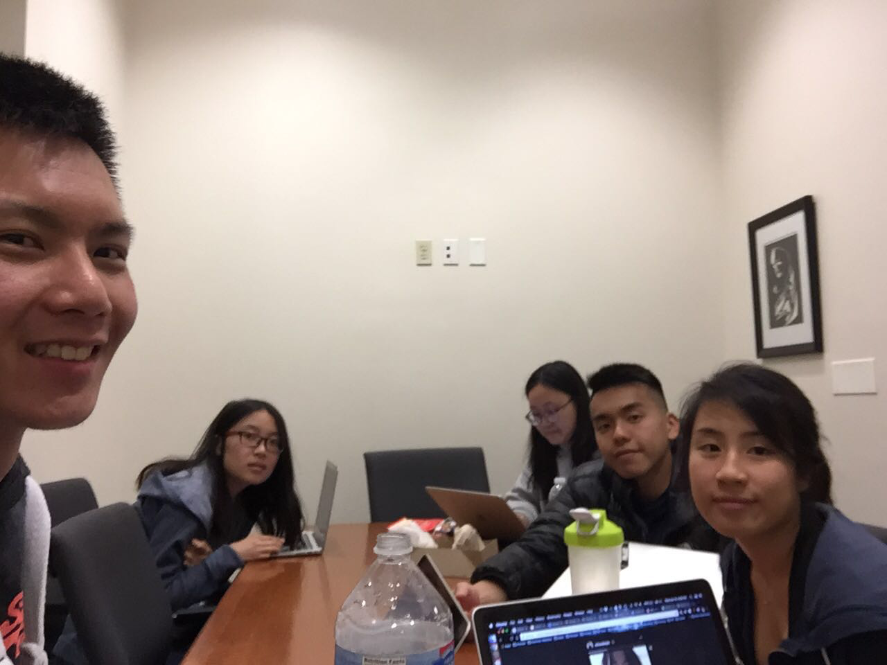

**Suggestions for Improvement**

Ryan:

Right now Server.java contains all the functionalities needed to gather images, build the collage and add the necessary filters. It would improve readability of our code if these functionalities were separated into different classes. Main.jsp also has all of our JavaScript functions all in one file. To separate HTML code with JS code, JS code should be in their own file. Having more comments for our testing classes would also be a huge advantage.

Joann:

I think we can improve the process of syncing the AWS S3 and MySQL databases, both with each other and on our own computers. I think this involves modifying credentials and automatically running scripts on start-up. This will help avoid problems in the future where we are simultaneously uploading to S3 or we are pulling stale data from the MySQL database.

Gong:

Gong agrees with Ryan that the Server class needs to be refactored so the readability improves. In addition, the current white-box tests need to be refactored so that each test file contains less test cases. For example, the test for filters can be splitted into 3 different test files. We should include the github repo link in the report as soon as possible.

Peixuan:

I think we need to add more test cases for most of the back-end features, and some of the front-end features, like login with an invalid username and password. Test cases for servlets need to get modified so that they actually test for functionalities other than just run through the servlets to get the code covered.

Lingyi:

I think we need to be more detailed in our project, such as the naming of the test cases, the number of options covered for each of the functionality, the UI of the main page. We also need to proofread our process report more carefully to avoid professionalism deduction. We need to commit our scrum report on time.

Tuling:

I think we definitely need to add more test cases for blackbox. Also, the frontend UI should be adjusted to be more suitable for collage display (the current UI was not initially designed to display collage but just to make collage options).

**Summary**

Our retrospective discussion highlighted that we need to spend more time on the planning phase for documentation, testing, and coding. With documentation, we need to make sure we Additionally, we need to consider how our customer’s priorities affect the order of the items in our backlog. By taking these actions, we as a team will have a clearer understanding of what needs to be accomplished during each sprint and the purpose behind each item.

Additionally, we need to spend more time focusing on the process of our sprints. This means ensuring we have written our tests and designed our system before beginning to implement features. Taking the extra time to do this will help prevent problems we experienced during this sprint, like our back-end and front-ends not fitting together and code containing errors being pushed. By investing more time in simple design, we can avoid the accidental creation of “God” classes. We will also have a more coherent understanding of how our code interacts and fits together.

In this next sprint, we will take care to make sure that we adhere to the correct process and that we invest sufficient amount of time in planning and testing. We will attend the office hours of the Professor, TAs, and CPs to review our documents and ask questions. We will focus on developing tests and designs before we start implementing. Lastly, we will spend more time discussing and documenting our discussions so that we can ensure we are all on the same page.prioritize creating the sprint backlog and pushing it to GitHub at the beginning of the sprint.